IMPORTANT: This documentation is correct as of 11/14/2025
This document is created for the windows implementation. Please reference the folder named “Mac OS Impletementation” for more details on deploying this solution for Mac OS devices.
SCEP communication flow overview
The following image demonstrates a basic overview of the SCEP communication process in Intune. Each step includes a link to an article with more prescriptive guidance.
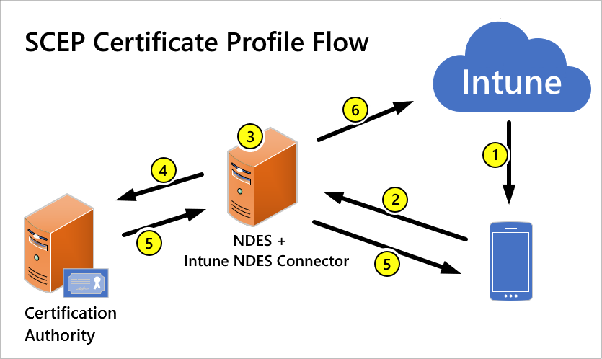
- Deploy a SCEP certificate profile. Intune generates a challenge string, which requires a specific user, certificate purpose, and certificate type.
- Device to NDES server communication. The device uses the URI for NDES from the profile to contact the NDES server so it can present a challenge.
- NDES to policy module communication. NDES forwards the challenge to the Intune Certificate Connector policy module on the server, which validates the request.
- NDES to certification authority. NDES passes valid requests to issue a certificate to the Certification Authority (CA).
- Certificate delivery to the device. The certificate is delivered to the device.
- Reporting of deployment to Intune. The Intune Certificate Connector reports the certificate issuance event to Intune.
When adding a new SSID:
Copy Settings from existing SSID. Ensure that you upload the RootCA server certificate from CA02 to the Meraki SSID. Save config profile and enable the SSID. Users that are added to the MerakiAuthenticationGroup will now be able to connect to the SSID.
IMPROTANT: Only 3 certificates and a Wi-Fi profile need to be pushed in Intune. RootCA server (device) certificate needs to be uploaded to Meraki SSID.
The following Wi-Fi template is pushed to devices:
MerkaiSCEPWifiAuthenticationTemplate
The following 3 certificates are pushed to devices:
RootCA, MerakiIDENTrustROOT, WifiSCEPCert
Follow this and look to the rest of this documentation for more details:
Deploy SCEP Certificate Connector Intune - NielsKok.Tech
Enable service logon | Microsoft Learn ß make sure to apply these permissions in addition to IIS and administrator group for service account.
Detailed YouTube Guide
S03E14 - Configuring NDES for SCEP Certificate Deployment (I.T)
S03E15 - Deploying SCEP certificates to Windows devices (I.T)
S04E06 - Network Access Control with Cisco ISE & Intune - (I.T)
Overview of Solution
- Set Up Certificate Authority (CA): Install and configure a local CA to issue SCEP certificates.
- Configure SCEP: Set up an SCEP template and the Certificate Connector on a local CC Server.
- Distribute CA Certificate via Intune: Use Intune to distribute the CA certificate to devices.
- Enroll SCEP Certificates Automatically: Use Intune to automatically enroll SCEP certificates.
- Configure Cisco Meraki for EAP-TLS: Set up the Meraki wireless network to authenticate using SCEP certificates.
- Test the Configuration: Ensure that devices can connect using the certificates.
Overview of Certificate Connector for Microsoft Intune - Azure | Microsoft Learn
Capabilities of the certificate connector
- The Certificate Connector for Microsoft Intune supports:
- PKCS #12 certificate requests.
- PKCS imported certificates (PFX file) for S/MIME email encryption for a specific user.
- Issuing Simple Certificate Enrollment Protocol (SCEP) certificates. When you use an Active Directory Certificate Services Certification Authority (CA), also called a Microsoft CA, you must also configure the Network Device Enrollment Service (NDES) on the server that hosts the connector.
- Use of SCEP with a third-party Certification Authority, doesn’t require use of the Certificate Connector for Microsoft Intune.
- Certificate revocation.
- Automatic updates to new versions. When servers that host the certificate connector can access the internet, they automatically install new updates to stay current. When a connector fails to automatically update, you can manually update the connector.
- Installation of up to 100 instances of the connector per Intune tenant, with each instance on a separate Windows Server. When you use multiple connectors:
- Each instance of the connector must have access to the private key used to encrypt the passwords of each uploaded PFX file.
- Each instance of the connector should be at the same version. Because the connector supports automatic updates to the newest version, updates can be managed for you by Intune.
- Your infrastructure supports redundancy and load balancing, as any available connector instance that supports the same connector features can process your certificate requests.
- You can configure a proxy to allow the connector to communicate with Intune.
- Certificate Connector should not be installed on the same server as Intune Connector for Active Directory.

General Prerequisites
Requirements for the computer where you install the connector software:
- Windows Server 2012 R2 or later.
o support Simple Certificate Enrollment Protocol (SCEP) certificates, the Windows Server that hosts the connector must meet the following prerequisites in addition to the general prerequisites:
- IIS 7 or higher
Network Device Enrollment Service (NDES) service, which is part of the Active Directory Certification Services role. The connector isn't supported on the same server as your issuing Certification Authority (CA). For more information, see Configure infrastructure to support SCEP with Intune.
Note
The Server installation must include the Desktop Experience and support use of a browser. For more information, see Install Server with Desktop Experience in the Windows Server 2016 documentation.
On the Windows Server, select to add the following Server Roles and Features:
- Server Roles:
  - Active Directory Certificate Services
  - Web Server (IIS)
- Features:
  - .NET Framework 4.7 Features
    - .NET Framework 4.7
    - ASP.NET 4.7
    - WCF Services
      - HTTP Activation
- AD CS > Role Services:
  - Network Device Enrollment Service - For the connector SCEP when you use a Microsoft CA, install, and configure the Network Device Enrollment Service (NDES) server role. When you configure NDES, you need to assign a user account for use by the NDES application pool. NDES also has its own requirements.
- Web Server Role (IIS) > Role Services:
  - Security
    - Request Filtering
  - Application Development
    - .NET Extensibility 4.7
    - ASP.NET 4.7
  - Management Tools
    - IIS Management Console
    - IIS 6 Management Compatibility
      - IIS 6 Metabase Compatibility
      - IIS 6 WMI Compatibility
In addition, NDES requires the following.NET Framework 3.5 Features:
  - .NET Framework 3.5
  - HTTP Activation
Requirements for SCEP certificate templates:
- Certificate templates you use for SCEP requests must be configured with permissions that allow the Certificate Connector service account to auto enroll the certificate.
- The certificate templates must be added to the CA.
- Transport Layer Security (TLS) 1. 2. For more information, see Enable support for TLS 1.2 in your environment in the Microsoft Entra documentation.
PowerShell script to enable TLS 1.2
- The server must meet the same network requirements as managed devices. See Network endpoints for Microsoft Intune, and Intune network configuration requirements and bandwidth.
- To support automatic updates of the connector software, the server must have access to the Azure update service:
  - Port: 443
  - Endpoint: autoupdate.msappproxy.net
- The Enhanced Security Configuration must be deactivated.
- On the Certificate connector server Enable Service Logon for the service account. Enable service logon | Microsoft Learn
- Make sure that the registry values in the following registry subkey map to the certificate template name correctly:
HKEY_LOCAL_MACHINE\SOFTWARE\Microsoft\Cryptography\MSCEP
Registry values:
  - SignatureTemplate
  - EncryptionTemplate
  - GeneralPurposeTemplate
The following is an example that shows an incorrect value for SignatureTemplate:
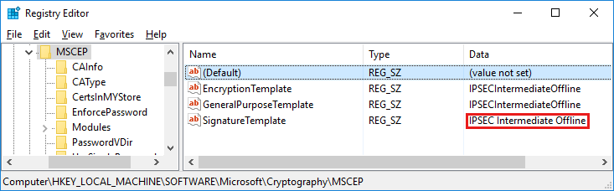
- Restart the Intune Connector Service on the NDES server after configuring the registry entries.

Certificate connector service account
The certificate connector requires an account to use as a service account. This account is used by the connector to access the Windows Server, communicate with Intune, and access the Certification Authority to service PKI requests.
The connector service account must have the following permissions:
- Logon as Service
- Issue and Manage Certificates permissions on the Certification Authority (required only for revocation scenarios).
Certification Authority MMC snap-in, right-click on the CA name and select Properties. On the Security tab, add the group and grant it Read, Log on as a service, Issue and Manage Certificates and Request Certificates permissions.
- Read and Enroll permissions on any certificate template that you use to issue certificates.
- Permissions to the Key Storage Provider (KSP) that’s used by PFX Import. See Import PFX Certificates to Intune.
The following options are supported for use as the certificate connector service account:
- SYSTEM
- Domain user - Use any domain user account that is an administrator on the Windows Server.
Step-by-Step Implementation Guide
Step 1: Set Up Certificate Authority

- Install AD Certificate Services:
  - Open Server Manager.
  - Add the Active Directory Certificate Services role.
  - Choose Certification Authority during the setup.
- Configure CA:
  - After installation, configure the CA as an Enterprise CA with default settings.
Step 2: Configure SCEP and Certificate Connector
Configure infrastructure to support SCEP certificate profiles with Microsoft Intune | Microsoft Learn
- Create SCEP Certificate Template:
  - Open Certificate Templates console (certtmpl.msc).
  - Duplicate the “User” template (or another suitable template).
  - Name it (e.g., "Intune SCEP Certificate").
  - In the Security tab, add the Intune service account with “Enroll” permissions.
  - In the Subject Name tab, choose “Supply in the request.”
- Publish the SCEP Template:
  - Open the Certificate Authority console.
  - Right-click on Certificate Templates and select “New” > “Certificate Template to Issue.”
  - Select your new SCEP certificate template and click OK.
- Install Certificate Connector on server separate from CA:
  - Download the Microsoft Intune Certificate Connector from the Microsoft site.
  - Install it on a Windows server in your environment, ensuring it can communicate with your CA and Intune.
  - Add the functionalities and roles required by the Certificate Connector.
  - Uninstall and Reinstall the Certificate Connector.
- Configure the Certificate Connector:
  - Add Service account to local IIS_IUSRS group in Computer Management How to add an account to the local IIS_IUSRS group on both servers.
  - Assigned the Logon as a service right for the service account in group policy editor on both servers. Computer Configuration > Windows Settings > Security Settings > Local Policies > User Rights Assignment> Log on as a service
  - Ensure that Certificate Connector Server is targeting the Root CA Server. You can check this in MMC under Certificate Authority.
  - Open the Certificate Connector configuration tool.
  - Sign in with your Intune admin account.
  - Configure the connector to use your CA and the published SCEP template.

Step 3: Distribute CA Certificate via Intune
Create trusted certificate profiles in Microsoft Intune | Microsoft Learn
- Export CA Certificate:
  - Export the Root CA certificate from the CA server using certmgr.msc
To identify the root certificate check if Issuer and Subject fields for equality.
  - Right click > all tasks > export > file location as .cer
- Import CA Certificate in Intune:
  - In the Intune Admin Center, navigate to Devices > Configuration > Policies > Trusted Certificate
  - Import the CA certificate and create the Trusted Certificate.
Step 4: Enroll SCEP Certificates Automatically
- Create SCEP Certificate Enrollment Profile:
  - In Intune, go to Devices > Configuration profiles > Create profile.
  - Choose Windows 10 and later for Platform and SCEP certificate for Profile type.
  - Select the Root CA Trusted Certificate we just create in Intune.
  - Enter the SCEP Server URL http://FQDN/certsrv/mscep/mscep.dll
  - Certificate Validity period: 3 days
  - KSP: Enroll to TPM KSP, otherwise Fail
  - Key Usage: Digital Signature, Key Encipherment
  - Key Bits: 2048
  - Hash SHA-2
  - Extended Key Usage: Client Authentication
- Configure the Profile:
  - Set the Certificate Authority to your local CA.
  - Choose the SCEP template created for SCEP certificates.
  - For Subject name, use a suitable configuration (e.g., DNS name or device name).
- Assign the Profile:
  - Assign the profile to the relevant device group.
Step 5: Configure Cisco Meraki for EAP-TLS
- Access Meraki Dashboard:
  - Log into your Cisco Meraki Dashboard.
- Set Wireless Configuration:
  - Navigate to Wireless > Configure > Access Control.
  - Set the “Authentication” method to “WPA2 Enterprise with my RADIUS server.”
  - Enter RADIUS server details (IP, port, and shared secret).
- Enable 802.1X Authentication:
Setup with Cloud PKI (These steps were referenced to implement via CA server instead of PKI):
Note: validity periods will be different
  - Choose EAP-TLS as the authentication method, requiring SCEP certificates.
Step-by-step walkthrough
  - The setup of the Microsoft Cloud PKI. Within Microsoft Intune navigate to Tenant administration > Cloud PKI and click on Create:

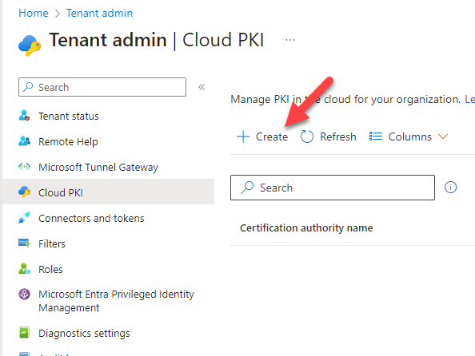
  - Root CA Creation
  - On the creation wizard fill in the name of the new Root CA
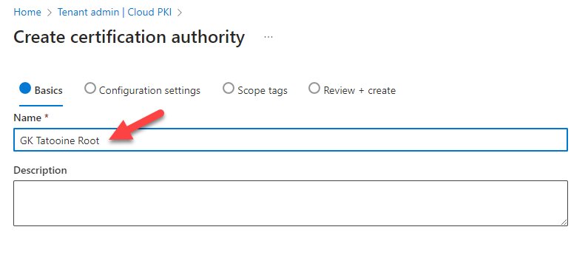
  - Select the CA type: Root CA with a Validity period: 25 years.
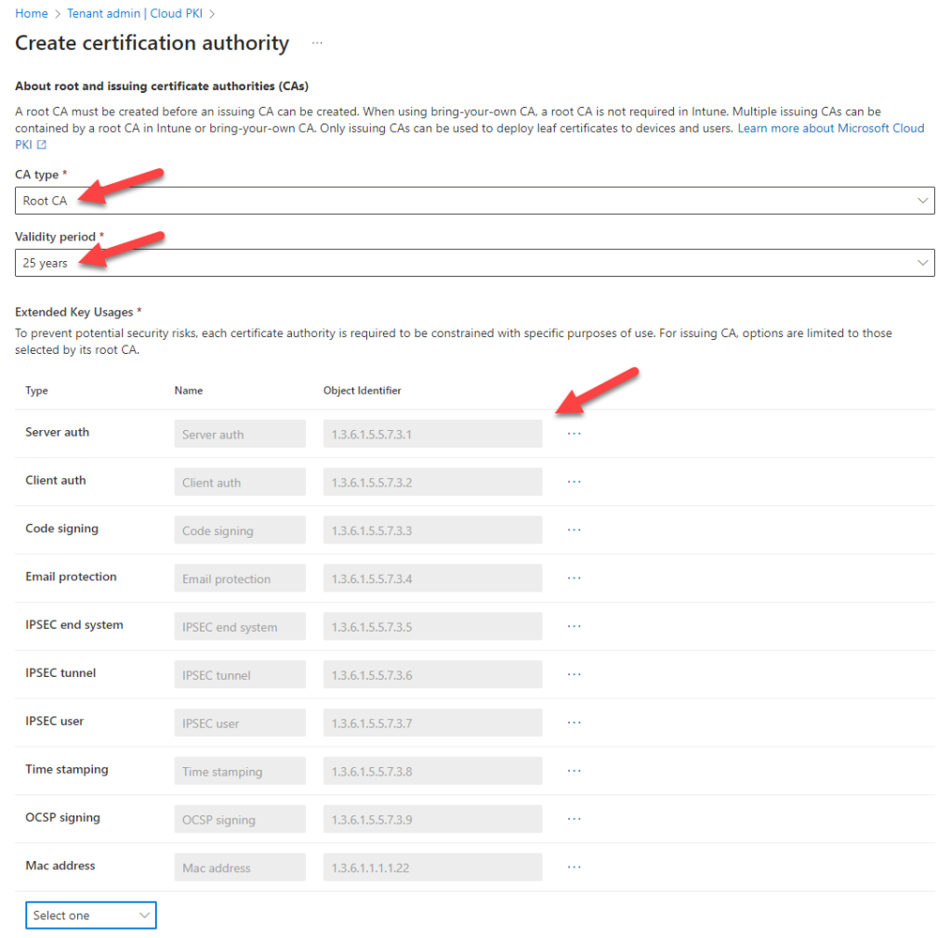
  - Extended Key Usages: select as minimum Server Auth and Client Auth. But you can add more if you wish.
  - Fill in all subject attributes for maximum compatibility
  - O as “your company name”
  - OU as “IT”
  - C as “2 digit country code”
  - ST as “your state”
  - Locality as “en-us” or “en-gb” or “en-au” or just leave this one blank, no big deal.
  - For the key size and algorithm, I’ve chosen the strongest one RSA-4096 and SHA-512
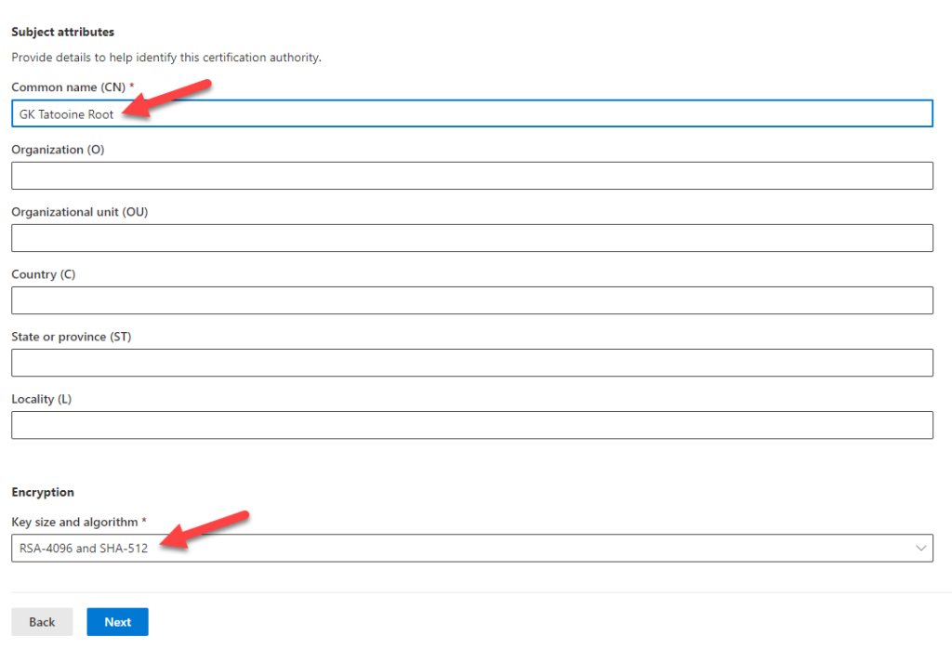
  - Then click next.
  - Issuing CA Creation
  - Let’s proceed with the Issuing CA by doing basically the same again and using CA type Issuing CA. We start with the name of the Issuing CA:
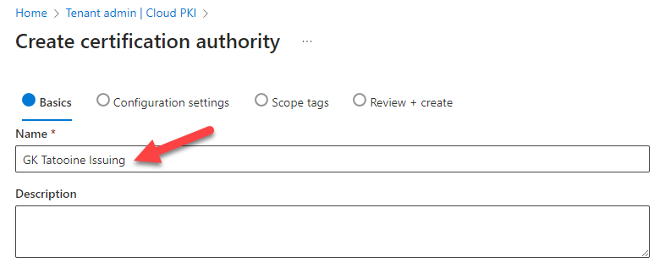
  - Choose the CA type Issuing CA
  - Select your newly created Intune based Root CA.
Validity period I chose the maximum of 10 years
  - The Extended Key Usages (EKU) can be chosen based on the ones I’ve added to the Root CA.
Extended Key Usages: select as minimum Server Auth and Client Auth. But you can add more if you wish.
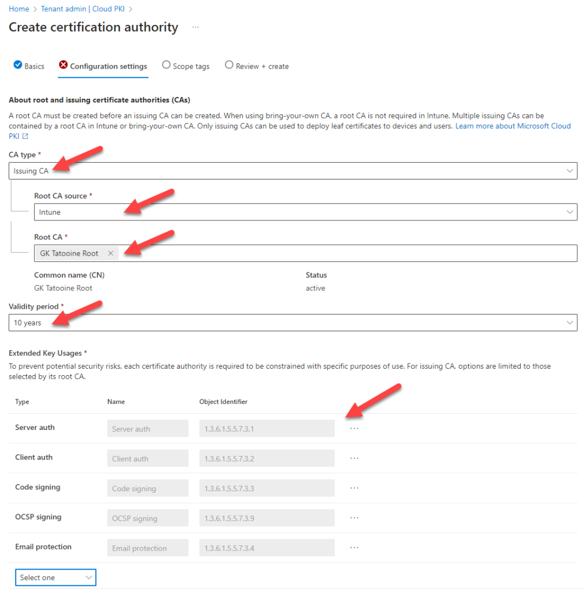
  - Fill in the Subject attributes and the key size as per Root CA
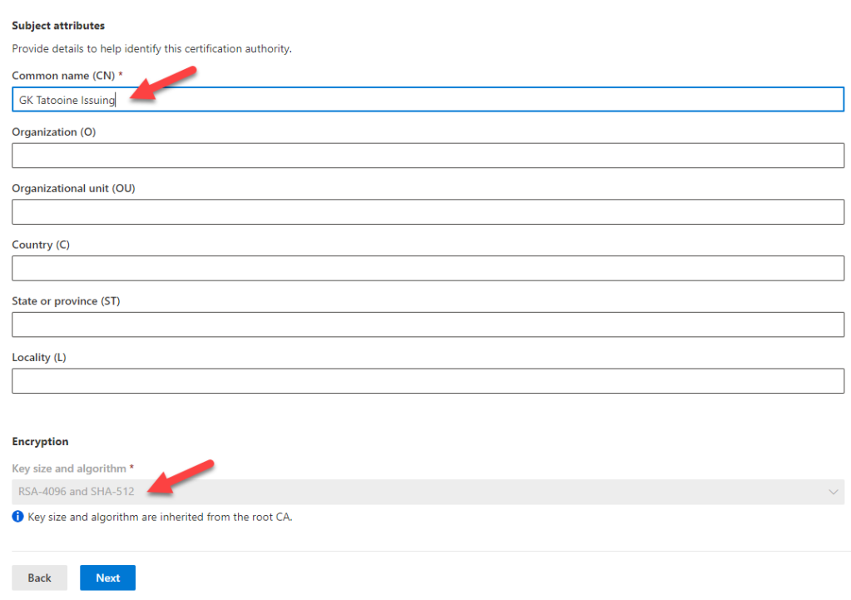
  - Finally on the summary page, click on Create:
  - 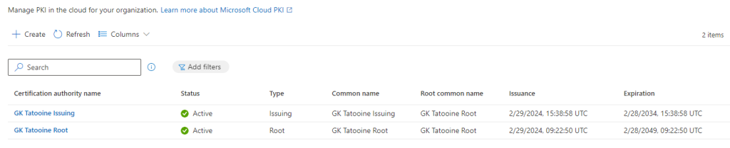
  - Now we are going to download the Root CA and Issuing CA certificate, as we want to deploy them later to our devices.
  - Click on the Root CA, select properties and then click on the Button Download to download the certificate.
  - Repeat for the Issuing CA
  - Also for the Issuing CA, copy/save the SCEP URI, we need this in Part 3
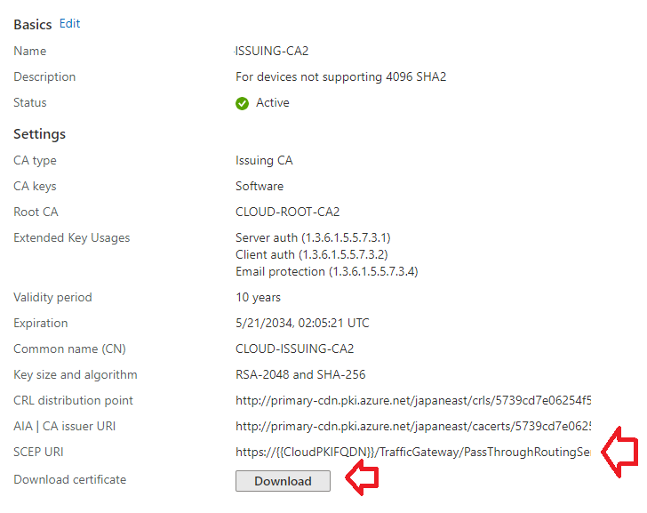
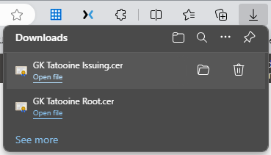
  - Part 2 – Meraki SSID.
  - Log in to Meraki and navigate to the Access Control page and select your desired SSID.
  - Set SSID to Enabled
  - Under Security, select Enterprise with Local Auth
  - Certificate authentication Enabled
  - Password authentication Disabled
  - Download the IdenTrust Root CA cert and put it with your previously downloaded Root CA and Issuing CA certificates. You will deploy this to your devices later with Intune. Here is a copy of it for convenience.
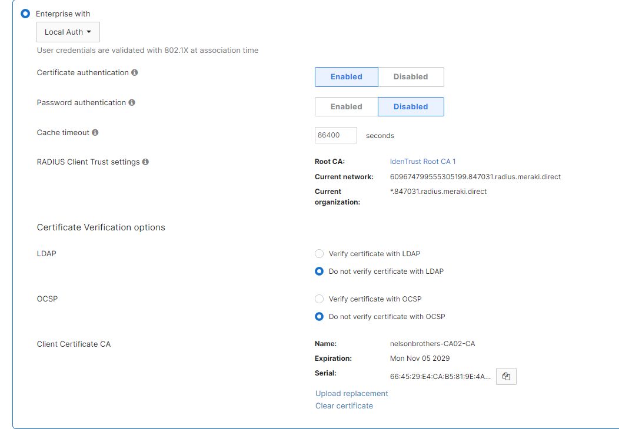
  - LDAP set to Do not verify with LDAP
  - OCSP set to Do not verify certificate with OCSP (at least until intune cloud PKI decides to support this function.)
  - Upload the certificate of your Issuing CA. In our instance this is the Root CA CA02. This will be the device certificate and not the Root Certificate.

  - Part 3 – Intune device profiles for windows devices.
(The home stretch) Process is similar for IOS.
  - We are going to deploy 4 profiles in this order:
  - Our Root CA certificate
  - Meraki IdenTrust Certificate
  - SCEP Profile (used in the WiFi Profile).
  - WiFi profile
  - Log in to intune, > Devices > Configuration Profiles:
  - First we create the Trust Profiles
  - Select Create then New Policy
  - Platform Windows 8.1 and later
  - Profile Type: Trusted Certificate
  - Click Next
  - Name: Enter the name of your Root CA or desired profile name.
  - Upload the .cer file of the Root CA you downloaded in Part 1.
  - Set destination store as Computer certificate store – Root.
  - Finish creating the profile setting the profile assignments to your Devices group.
  - Repeat these steps for the Issuing CA and Iden Trust CA certificates you downloaded also to the Computer certificate store – Root.

  - Second we create the SCEP Profile for our devices.
  - Select Create then New Policy
  - Platform Windows 8.1 and later
  - Profile Type: SCEP Certificate
  - Give it a name and click next.
  - Certificate type set as Device
  - Subject Name as CN={{AAD_Device_ID}}
  - Subject Alternative name as
  - DNS {{AAD_Device_ID}}
  - DNS {{DeviceName}}
  - Validity period as 1 Years
  - Key storage provider (KSP) set to Enroll to Software KSP.
  - Note (This is because some TPMs don’t support/like 4096 keys)
  - Key Usage select both Key encipherment and Digital signature
  - Key Size 4096
  - Hash algorithm SHA-2
  - Root Certificate Select your Root CA.
  - Extended key usage Client Authentication
  - Note: Don’t select Any – this wont work with Cloud PKI
  - SCEP Server URLs: Paste in the SCEP URI we saved in Part 1. If you don’t have it go to your Issuing CA and re-copy.
  - Save and assign to your Devices group.
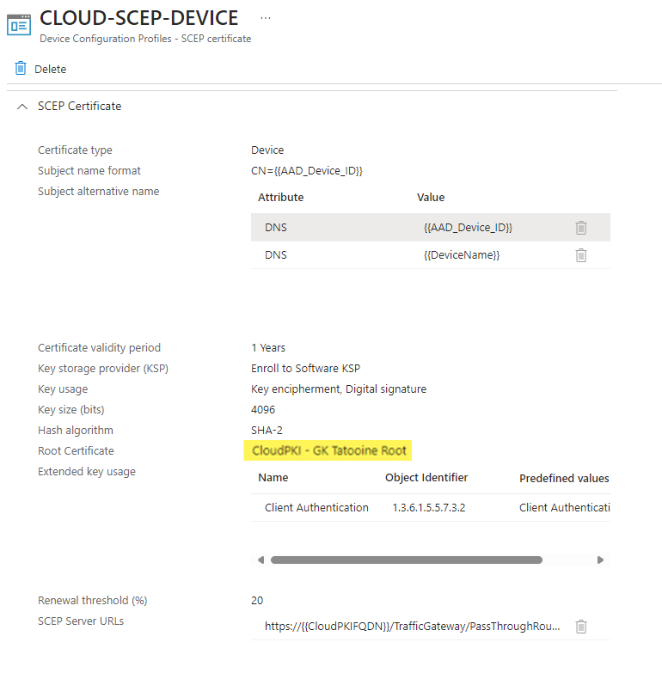

  - If the assignments are made you should get the Root Certificates on the device(s) and a device certificate.

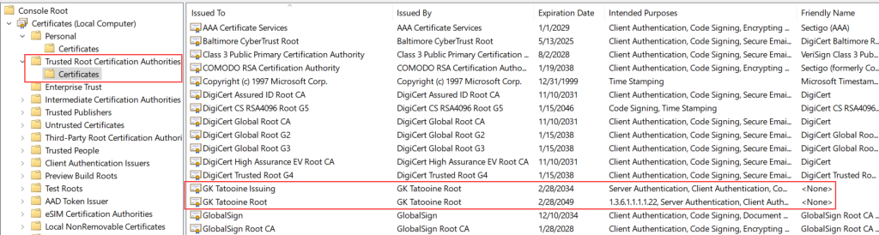
  - and also, the device certificate issued by the MS Cloud PKI:
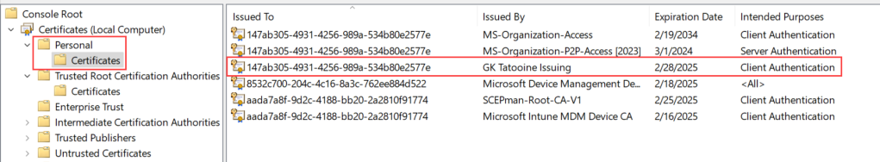

  - Third and finally we create the WIFI Profile for our devices.
  - Select Create then New Policy
  - Platform Windows 10 and later
  - Profile Type: WiFi
  - Click Next
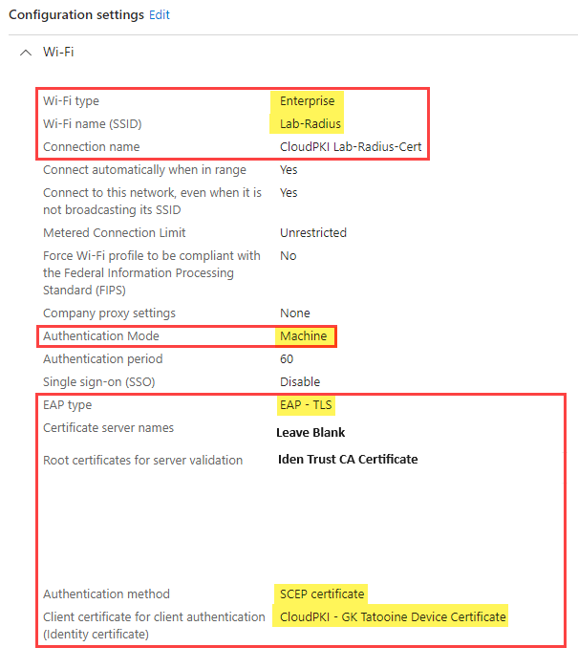
  - 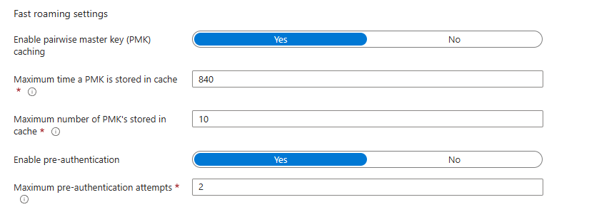

Step 6: Test Configuration
- Enroll Test Device:
  - Ensure a test device is enrolled in Intune.
  - Verify that it receives both the CA certificate and the SCEP certificate.
- Connect to Wi-Fi:
  - Attempt to connect to the configured SSID.
  - Select the network, click “Connect,” and monitor for a successful connection.
Step 7: Push to Production
  - On the CA server change Intune SCEP Certificate in the General tab, adjust the validity period to 6 weeks.
  - Change CertAuth SSID in Meraki name to reflect the change from testing.
  - Keep the original Internal SSID until all devices are migrated to Intune.

Creating and Using SCEP Certificate Profiles with Intune
Use SCEP certificate profiles with Microsoft Intune | Microsoft Learn
Creating Certificate Profile in Intune
Create trusted certificate profiles in Microsoft Intune | Microsoft Learn
Configuring SCEP
Configure infrastructure to support SCEP certificate profiles with Microsoft Intune | Microsoft Learn
Meraki 802.1X Certificate Authentication
https://documentation.meraki.com/MR/Encryption_and_Authentication/Meraki_Local_Authentication_-_MR_802.1X#Certificate_Caching_(Certificate_Auth)
Certificate Connector for SCEP
https://learn.microsoft.com/en-us/mem/intune/protect/certificate-connector-overview
Helpful for The Meraki Side of The Configuration
https://community.meraki.com/t5/Wireless/Azure-Cloud-PKI-is-now-released-how-do-we-hook-Meraki-AP-to-it/m-p/230754

Prerequisites for the Certificate Connector for Microsoft Intune
Prerequisites for the Certificate Connector for Microsoft Intune | Microsoft Learn

Another Step-by-Step Guide
NDES and SCEP setup for Intune- A Complete Guide! – EverythingAboutIntune

Use certificates for authentication in Microsoft Intune
Types of certificate that are supported by Microsoft Intune | Microsoft Learn

Configure and use PKCS certificates with Intune
Use a PKCS certificate profile to provision devices with certificates in Microsoft Intune | Microsoft Learn
If you need to remove CA
Remove Enterprise Windows Certificate Authority - Windows Server | Microsoft Learn

